Weather Data Analysis

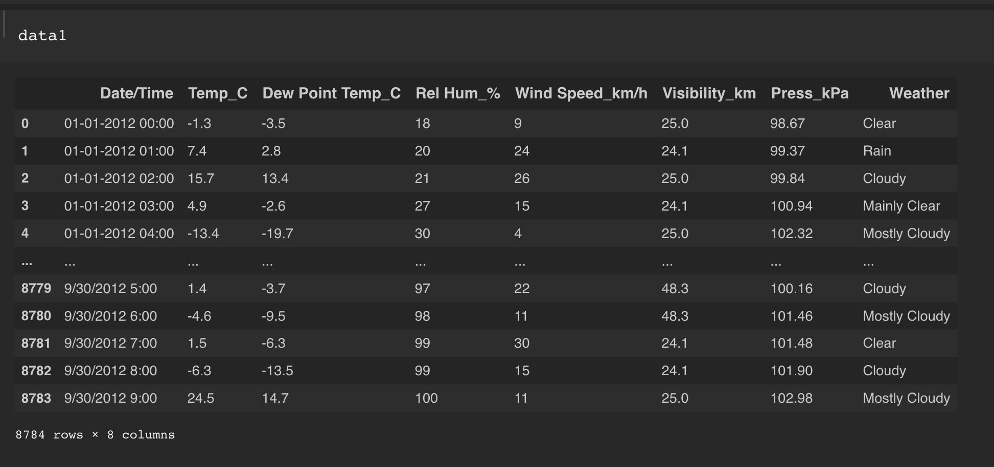

1.Find the Unique “Wind speed” values in the data?

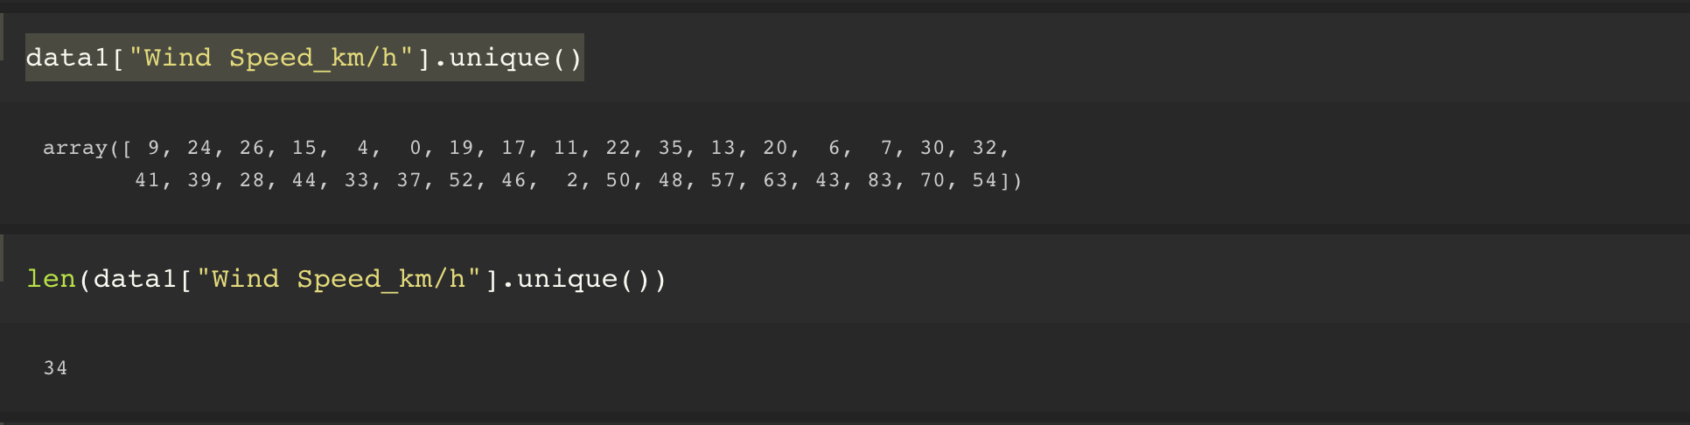

Analysis:- According to the Weather report, no of Unique values in the Wind speed is 34

2. Find the Number of tImes the weather is exactly clear?

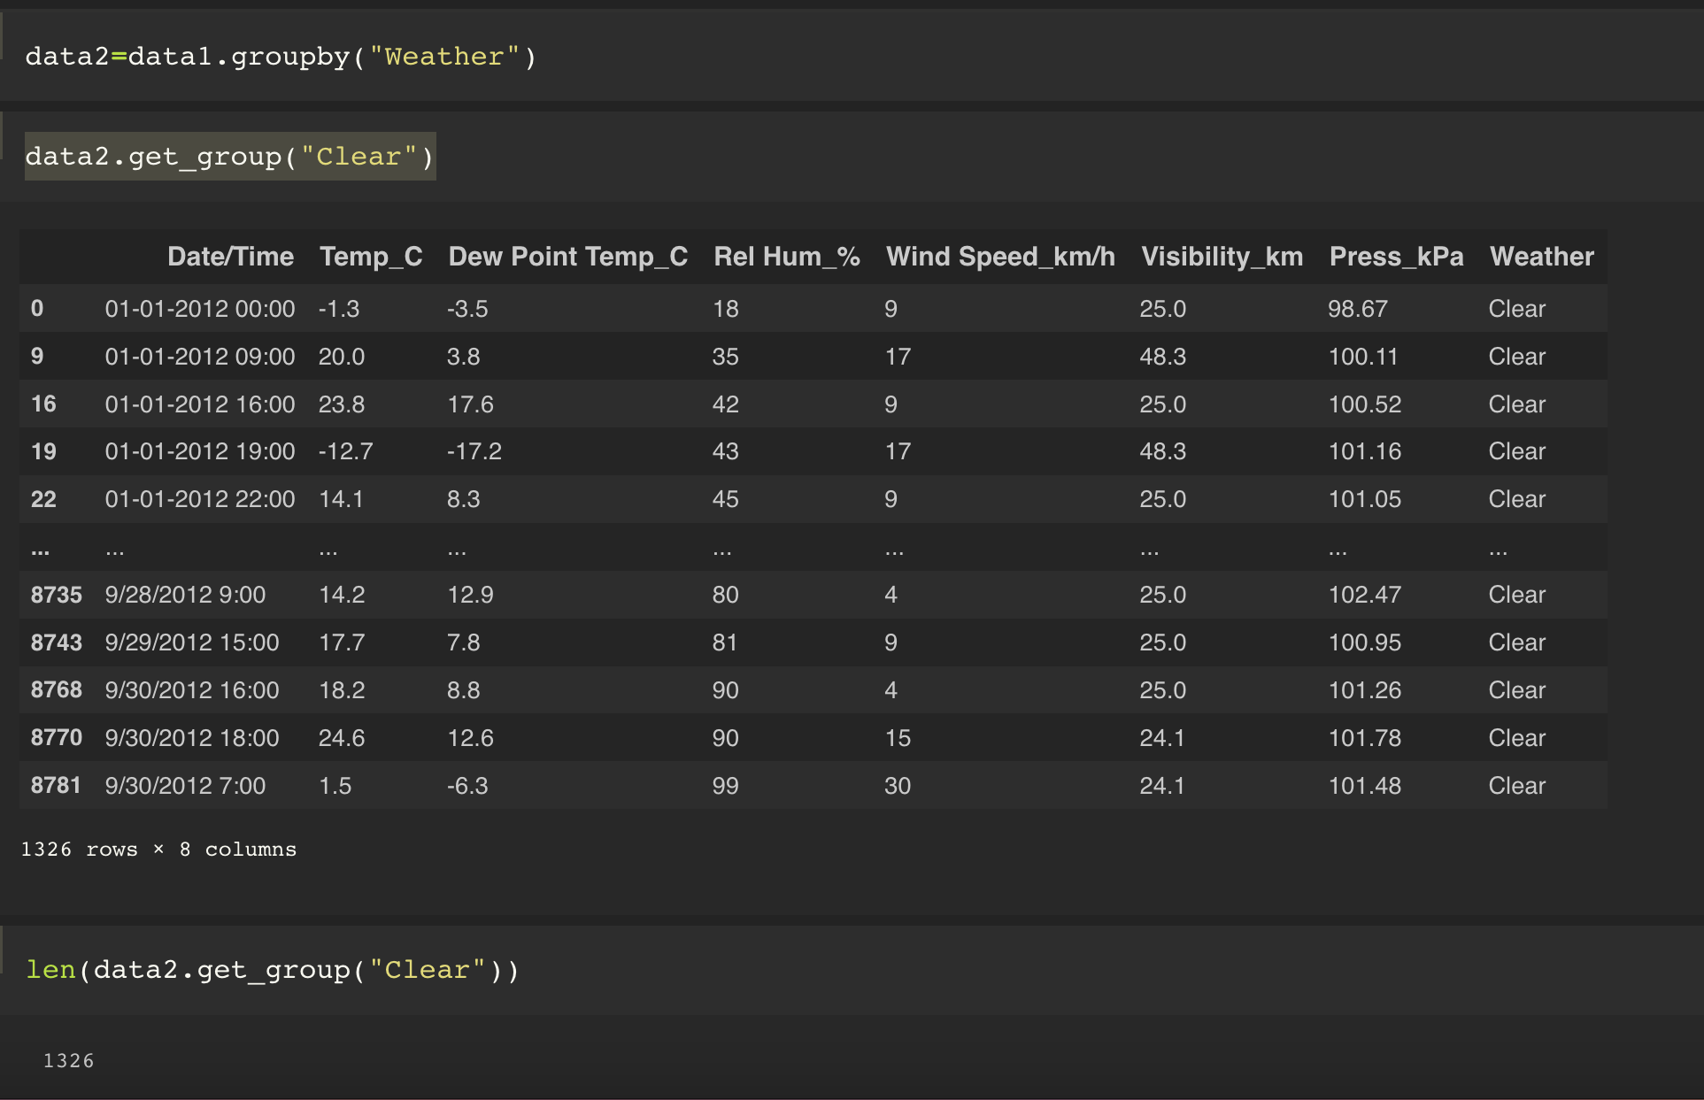

Analysis:- According to the Weather data the no of days the Weather was clear was 1326 Days.

3. Find the number of times the “Wind Speed '' was Exactly 4 KM/h?

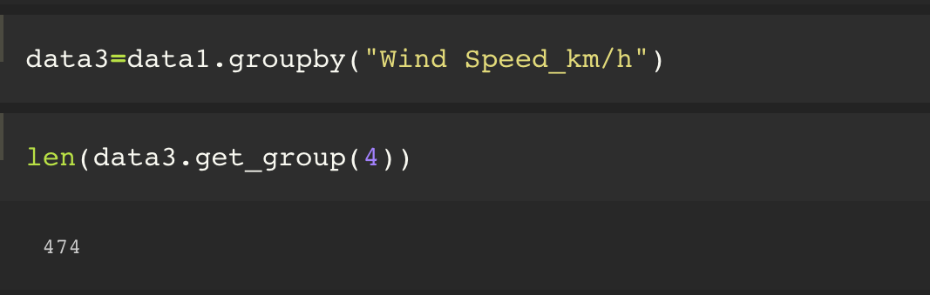

Analysis:- According to the Weather report, the number of times The wind speed was exactly 4 Km/h is 474 times.

4.Find out the Null Values in the data?

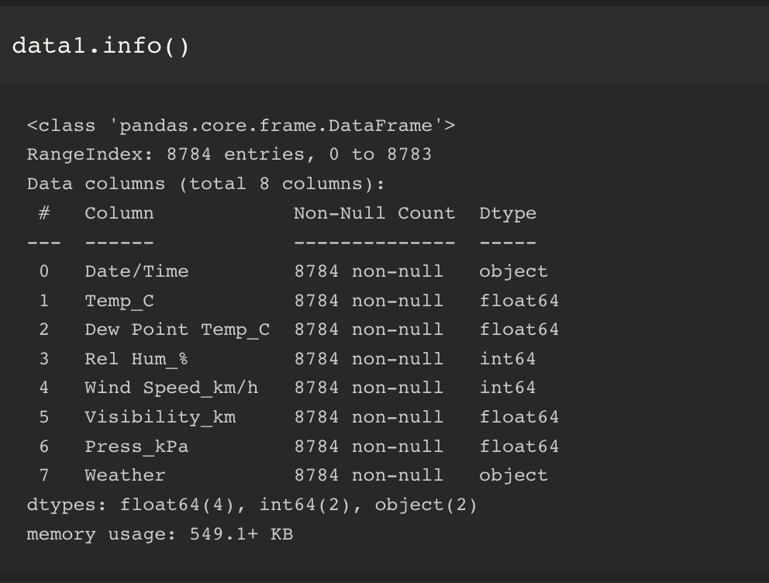

Analysis:- According to Weather report there are no Null values.

5. Rename the column name 'Weather' of the dataframe to 'Weather Condition'.

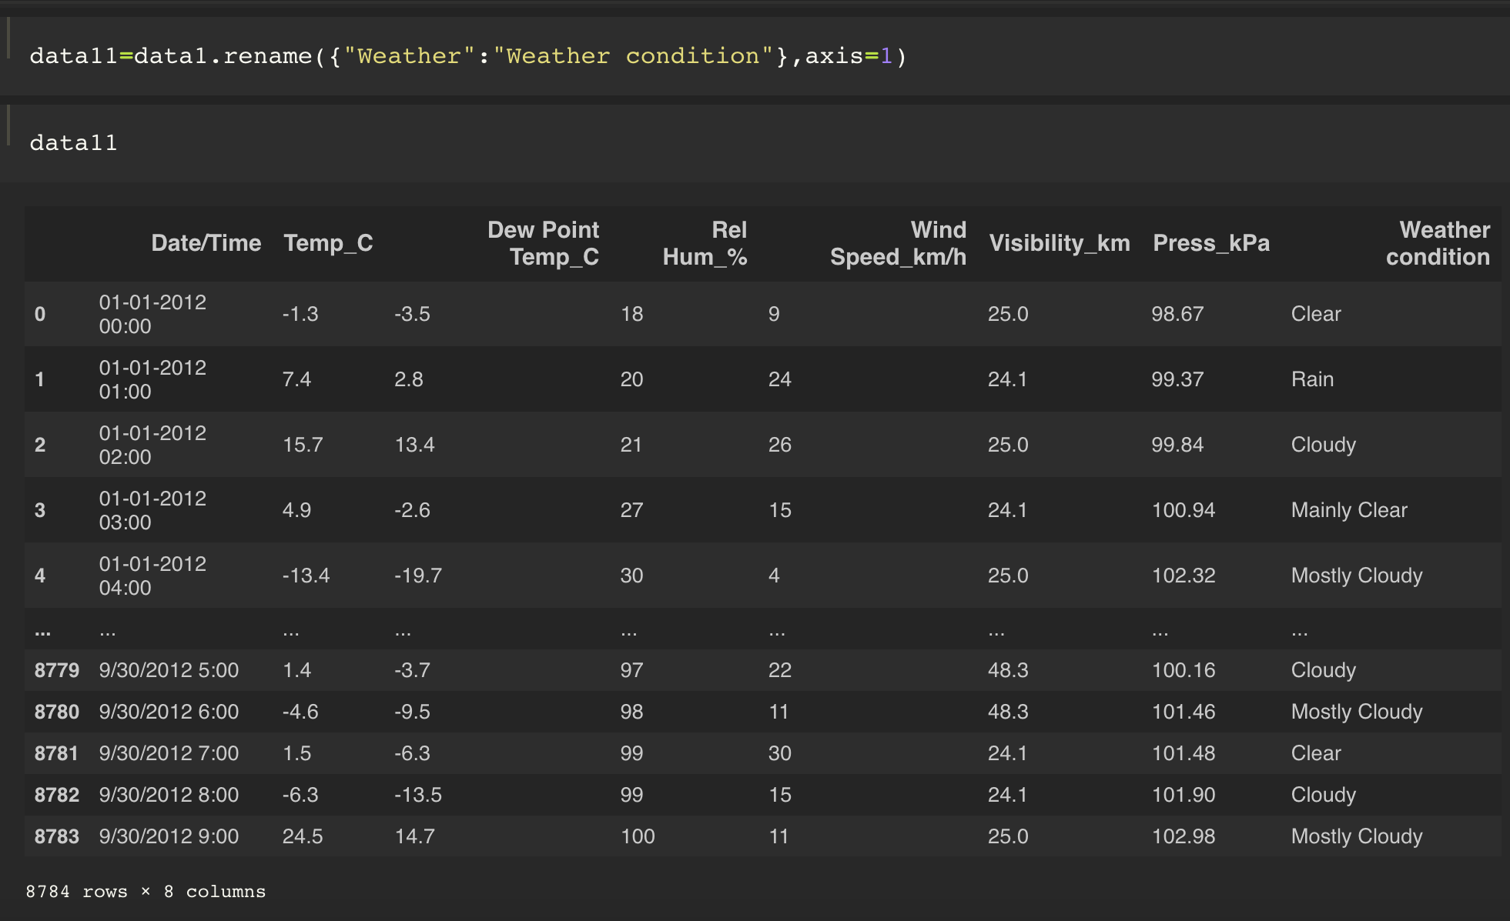

Analysis:In Weather data the column “Weather” has been renamed by “Weather Condition

6. What is the mean 'Visibility' ?

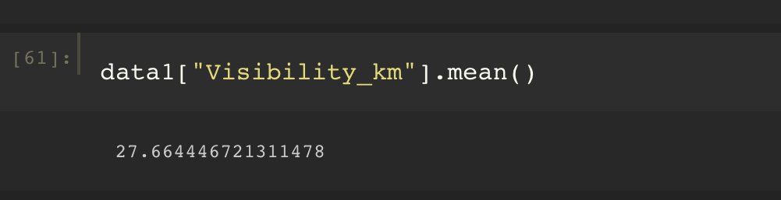

Analysis:- According the Weather report the Average visibility is 27.9

7. What is the Standard Deviation of 'Pressure' in this data?

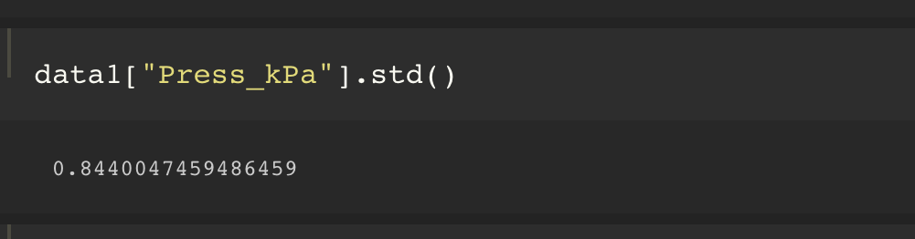

Analysis:- According to the Weather data report the standard deviation for Pressure is 0.84

8. What is the Variance of 'Relative Humidity' in this data ?

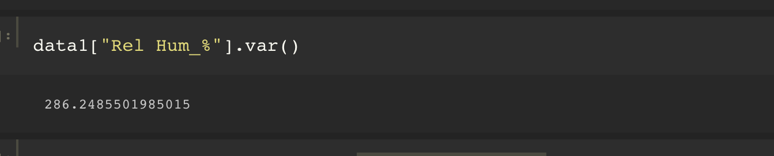

Analysis:- According to the Weather data report Variance for Relative Humidity is 286.2

9. Find all instances when 'Snow' was recorded.

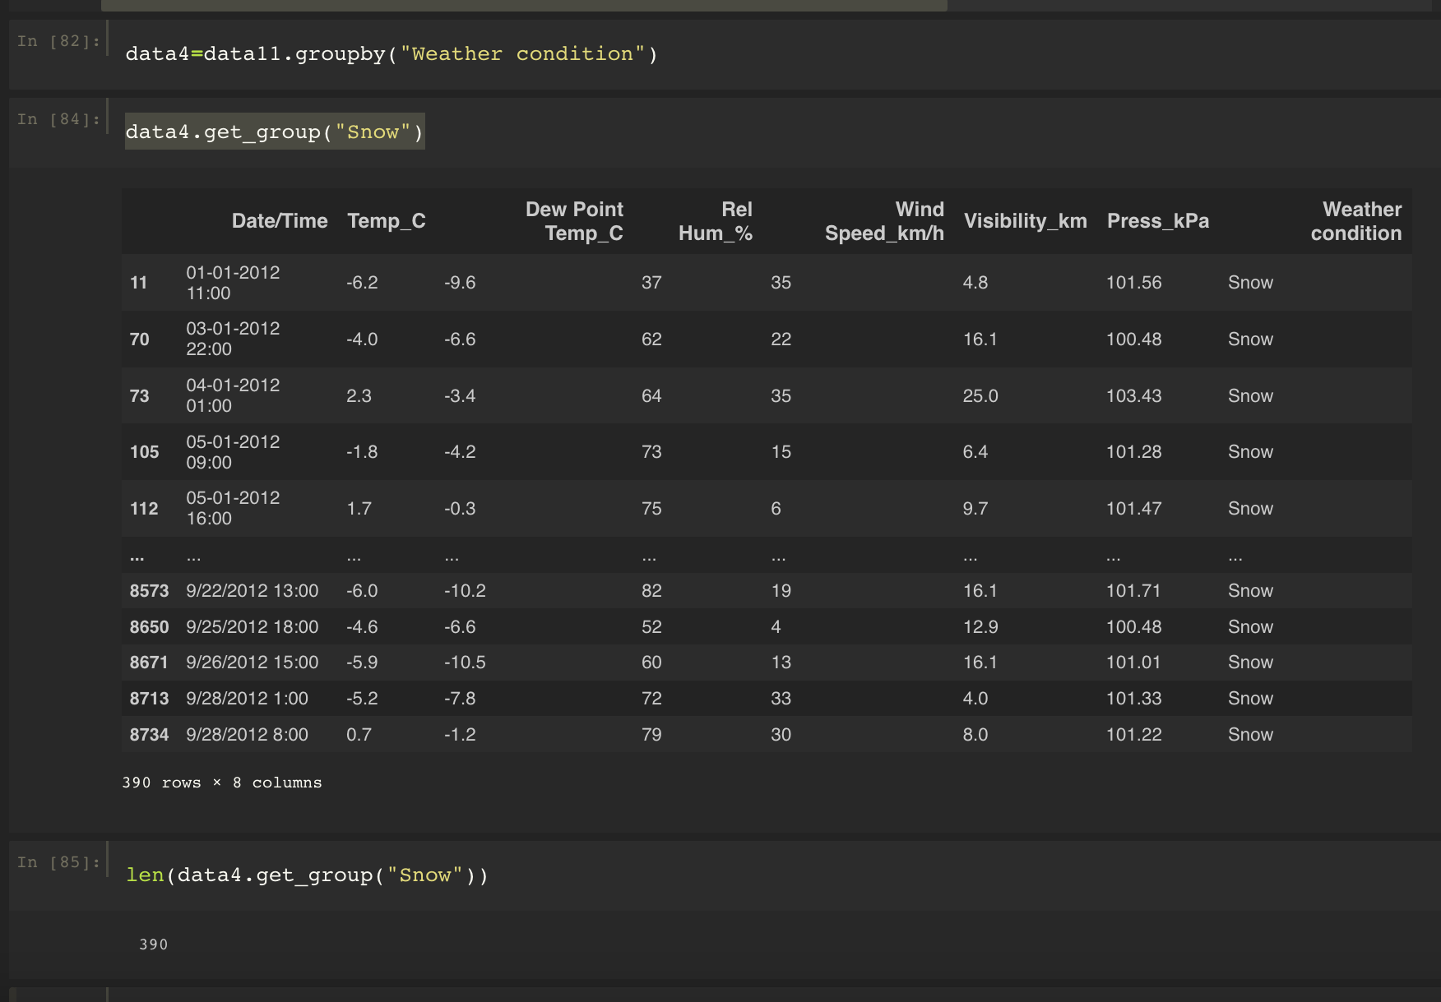

Analysis:- According to the Weather report, the weather condition of snow was for 390 Days out of 8784 Days.

10. Find all instances when 'Wind Speed is above 24' and 'Visibility is 25'.

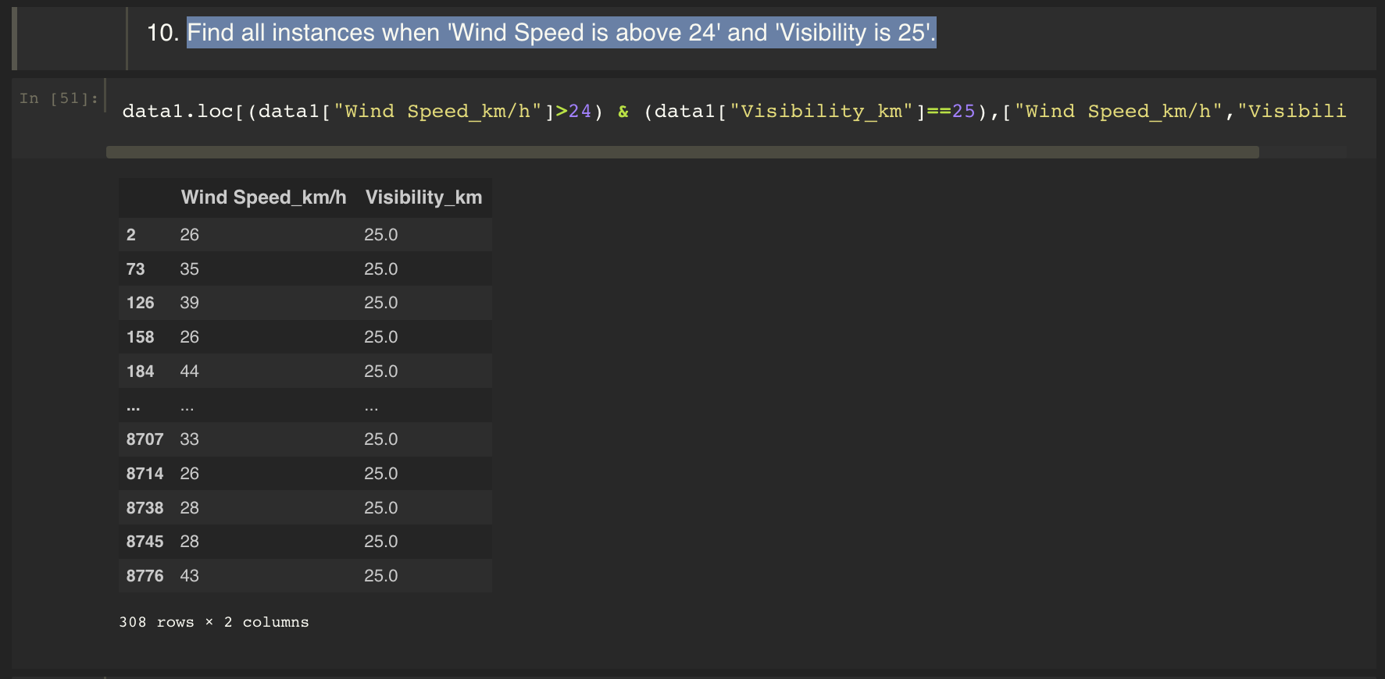

11.What is the Mean value of each column against each 'Weather Condition ?

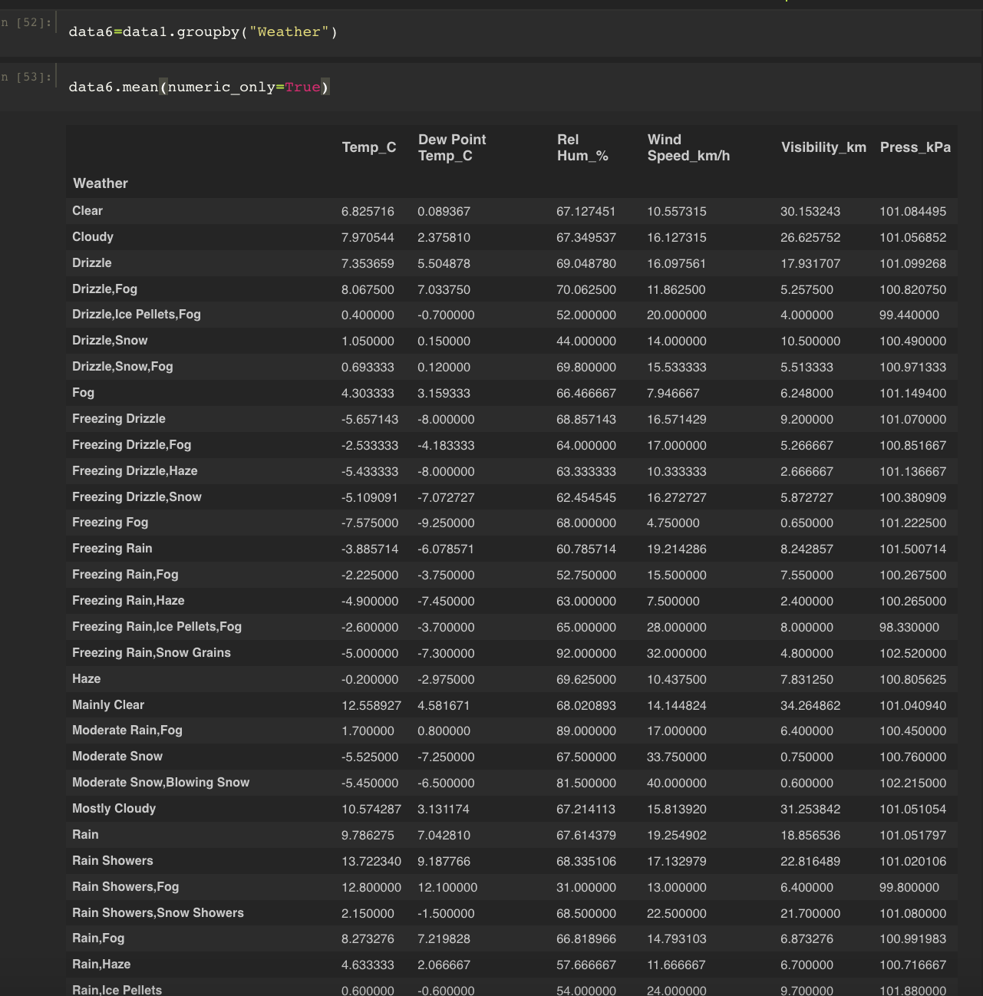

12. What is the Minimum & Maximum value of each column against each 'Weather Condition ?

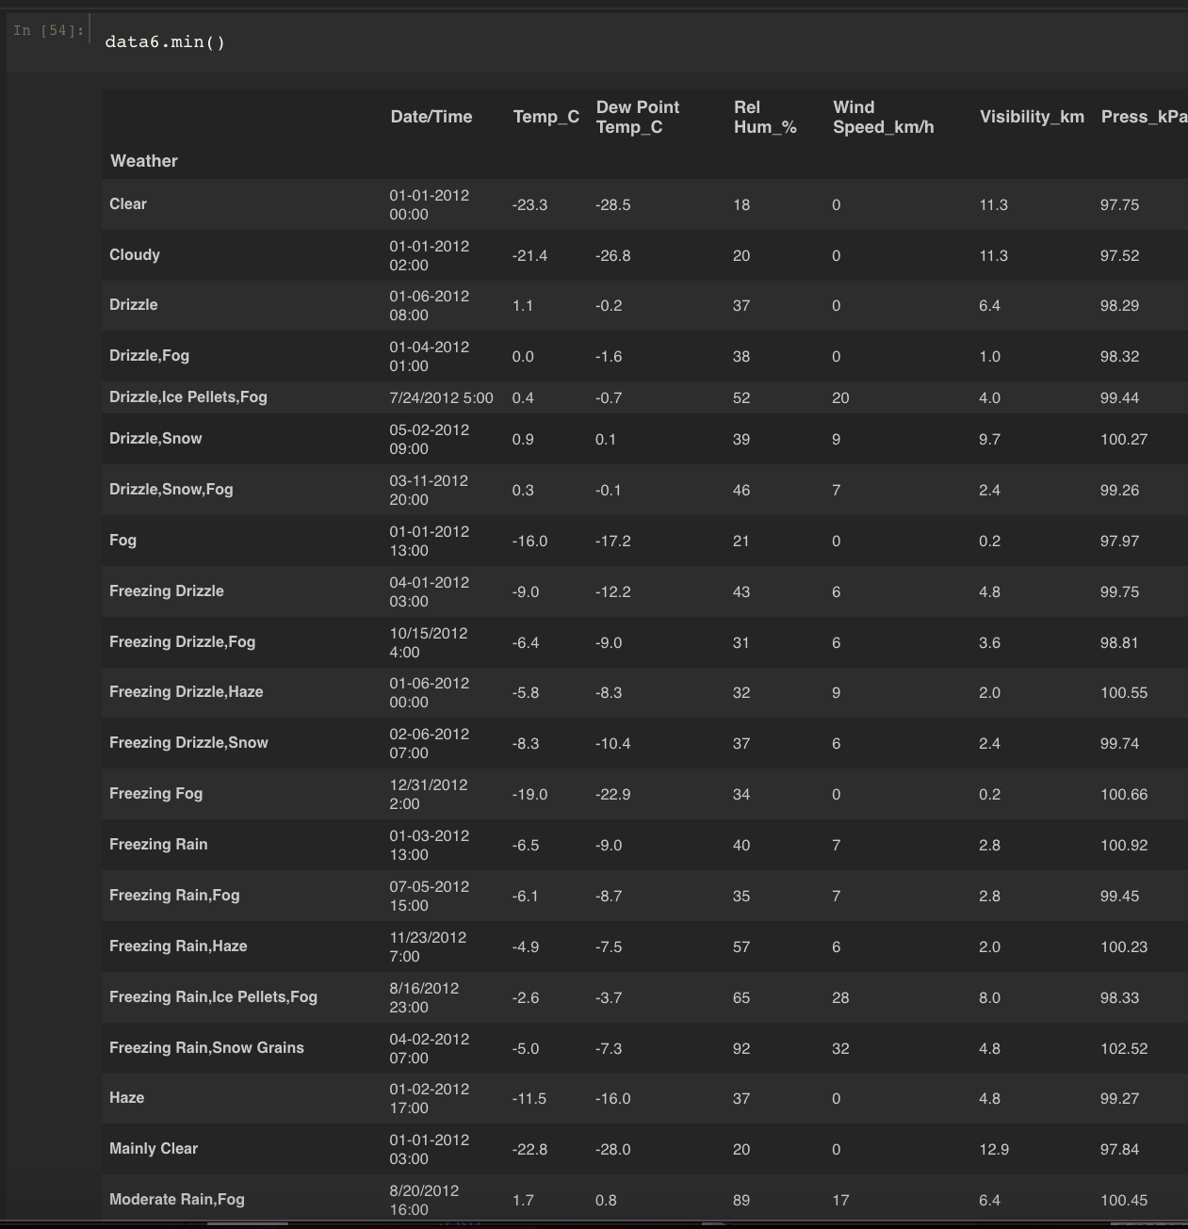

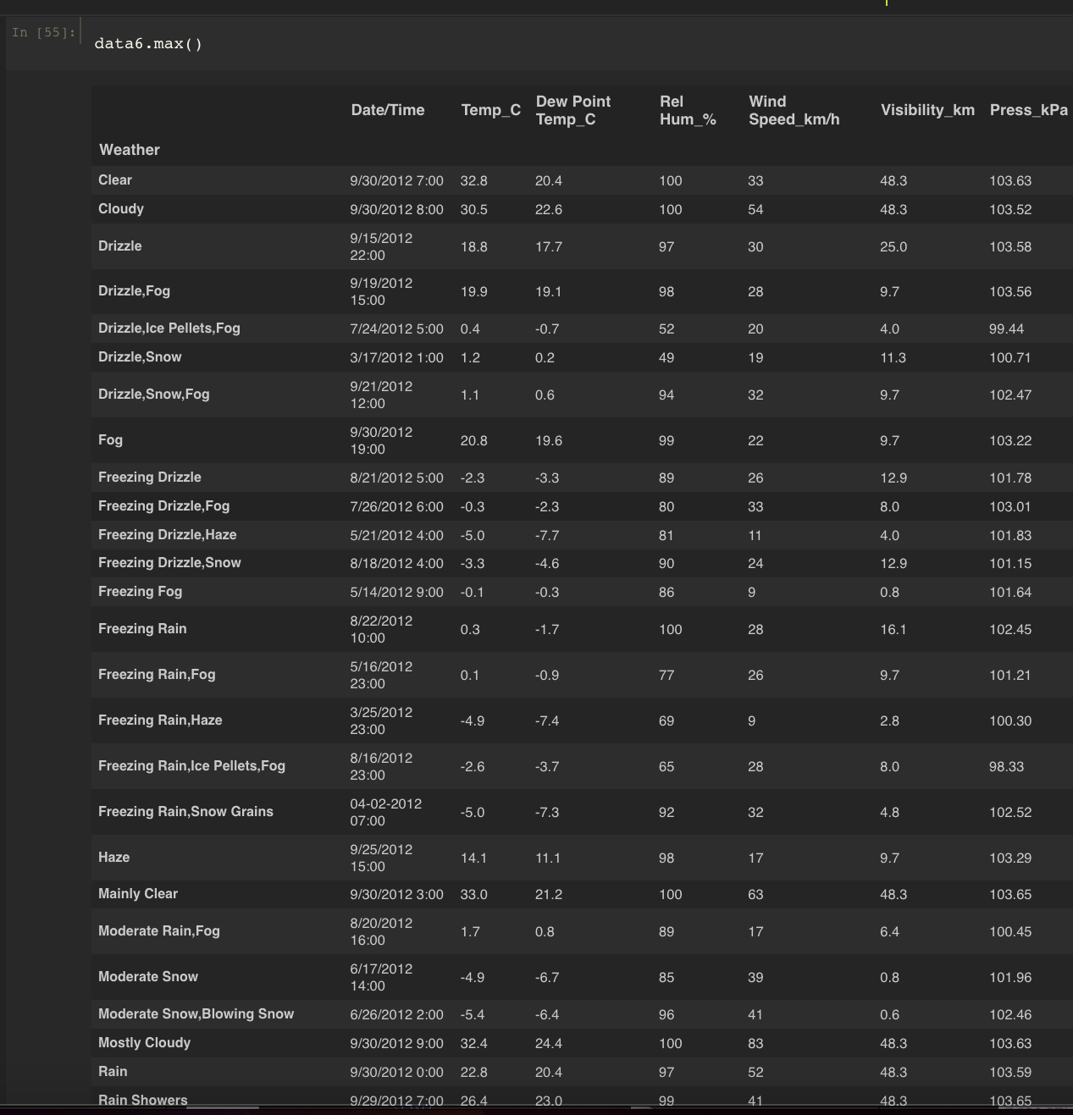

13.Show all the records where wether condition is foggy?

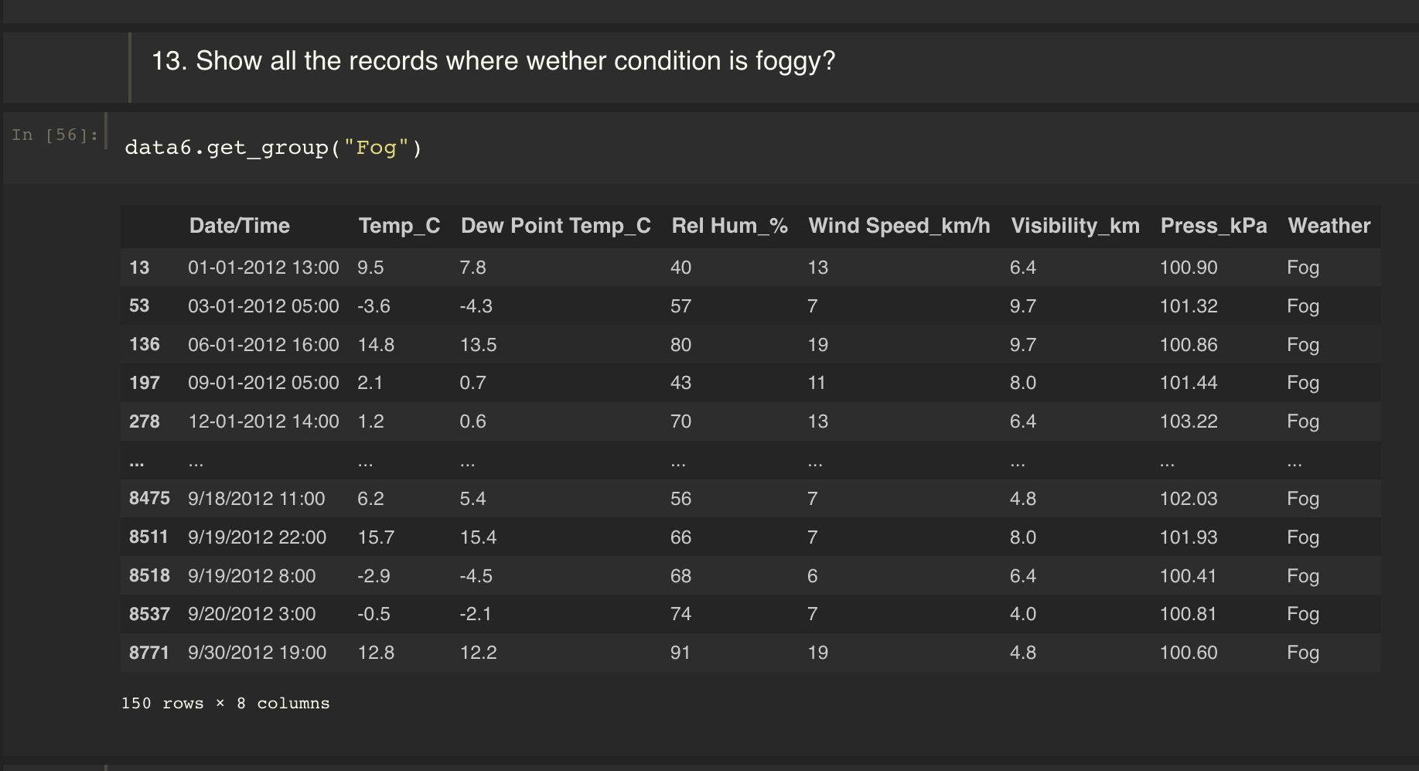

14.Find all instances when 'Weather is Clear' or 'Visibility is above 40'.

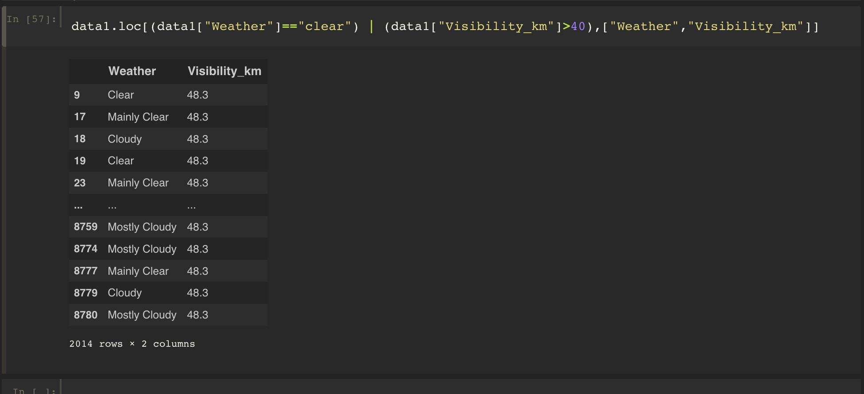

15.Find all instances when

Weather is Clear' and 'Relative Humidity is greater than 50'

or

'Visibility is above 40'

